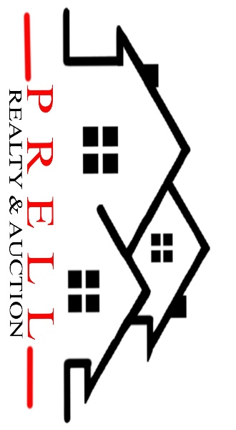
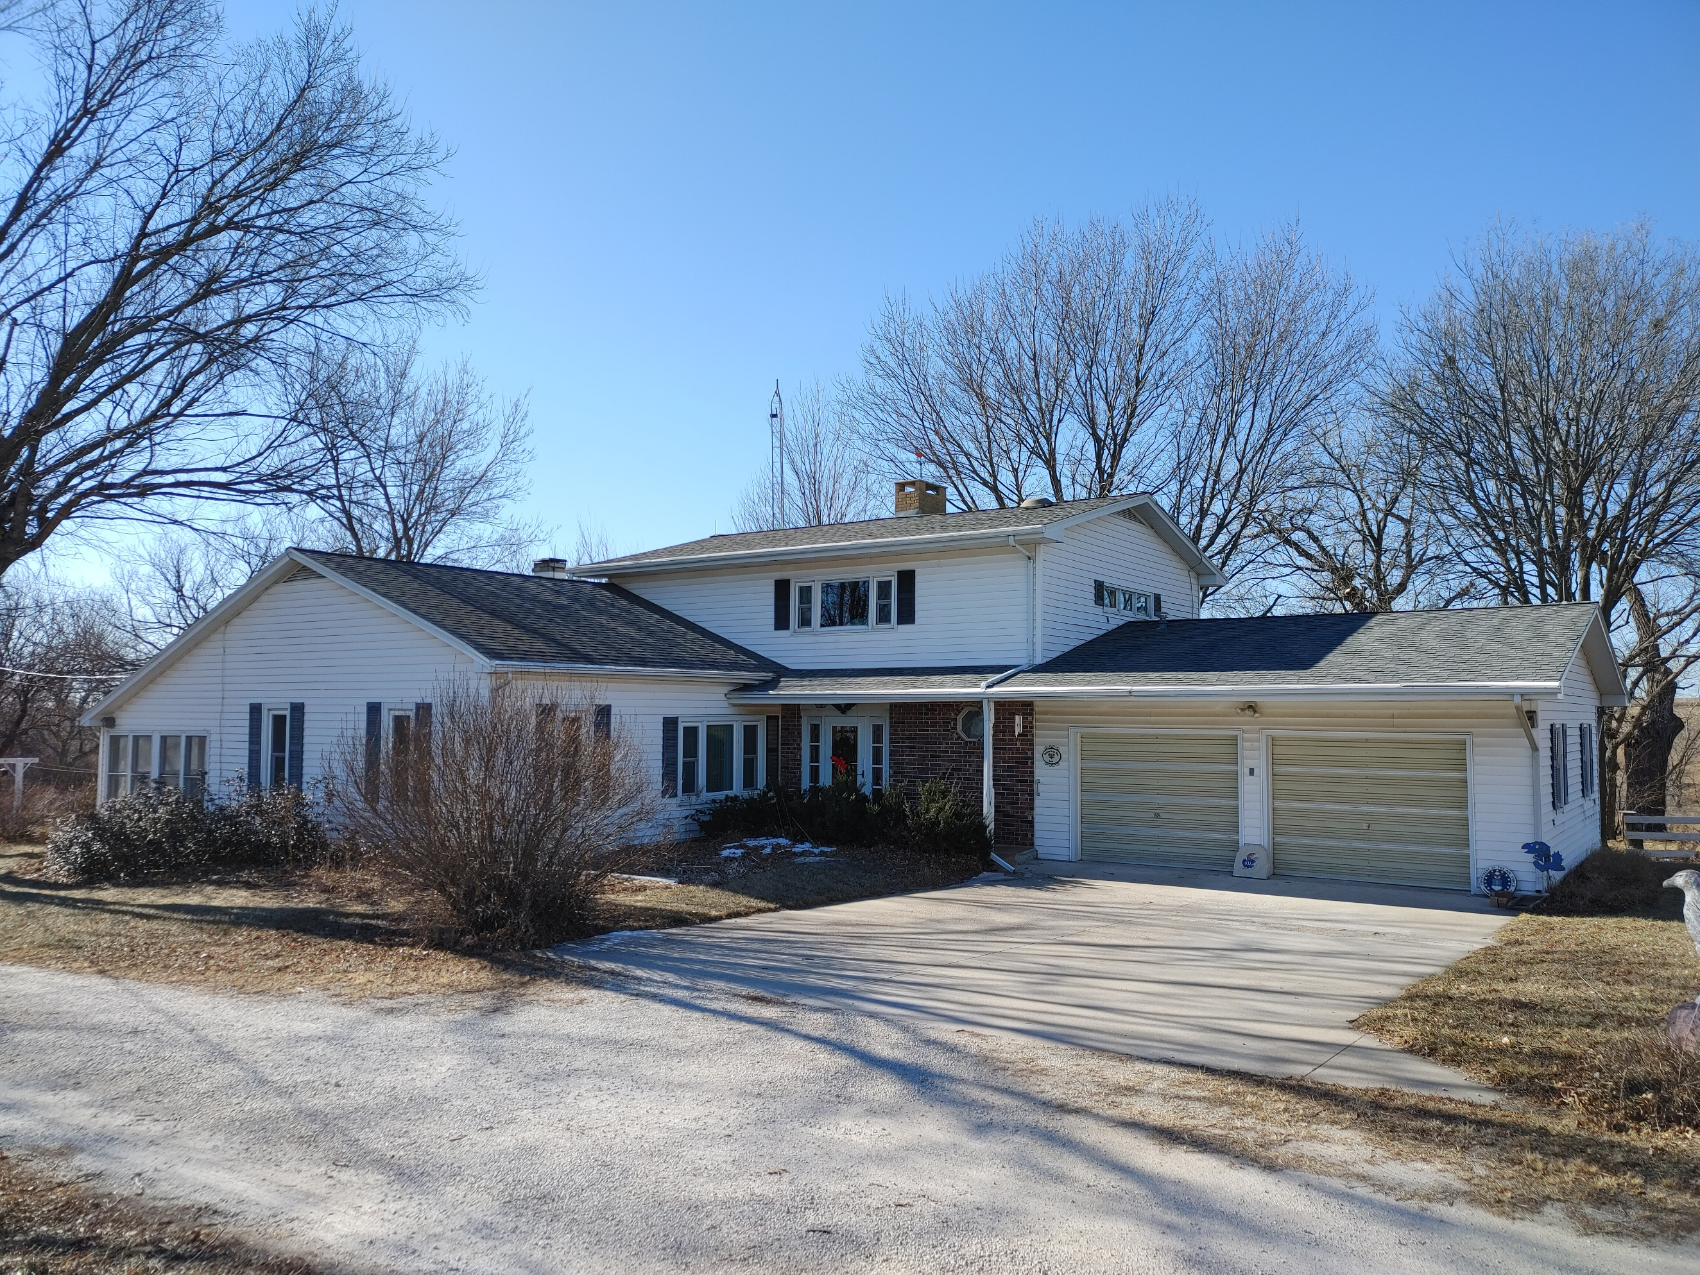
1042 Pony Express Hwy, Marysville KS 66508

Address_1319 Pony Express Highway________

Asking Price: $__385,000_______________
# Of Bedrooms | 4
# of Bathrooms | 2
Square Footage | 2500
Year Built | 1900
Property Tax
Co. Tax Appraisal $

Type of A/C__ Electric _____________________
Type of Heat__ propane__ _____________________
Type of Water Heater__propane ____ _____________________
Floor Covering
x | Carpet
x | Tile
x | Hardwood
x | Linoleum

NOTES

Roof
 | Metal
x | Shingle
 | Slate
 | Tile
 | Other

Exterior
x | Brick
 | Concrete
 | Metal
 | Shingle
 | Stucco
x | Vinyl
 | Wood
 | Other

Parking
 | Carport
2 | Garage Attached
 | Garage detached
 | Off Street
 | On Street

Indoor Features
x | Attic
x | Ceiling Fans
 | Double Pane Windows
x | Fireplace
x | Intercom System
 | Jetted tub
 | Security System
 | Skylights
 | Vaulted Ceiling

Architectural Style
Bungalow
Colonial
Contemporary
Loft
Victorian
Ranch
Split-Level
Other

Outdoor Amenities
x | Porch
x | Barbecue Area
 | Deck
 | Fenced Yard
 | Pool
 | Sprinkler System

Basement
 | Finished
 | Unfinished
x | Partially Finished
 | None
 | Crawl Space
 | Strom shelter

Appliances
x | Dishwasher
x | Dryer
 | Freezer
x | Garbage Disposal
x | Microwave
x | Range/Oven
x | Refrigerator
 | Trash Compactor
x | Washer

Rooms
x | Breakfast Nook
 | Dining Room
x | Family Room
 | Laundry Room
x | Master Bath
 | Mud Room
x | Office
x | Pantry
x | Walk-in Closet

